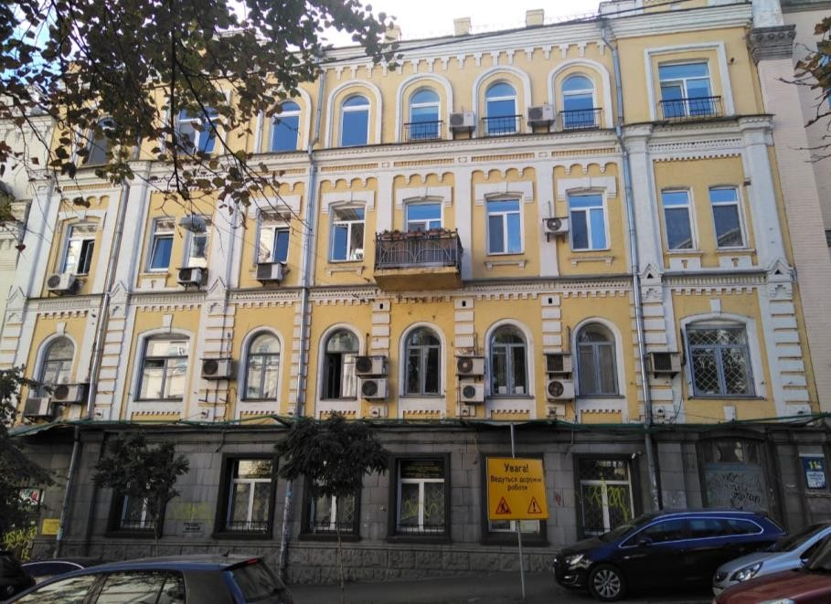
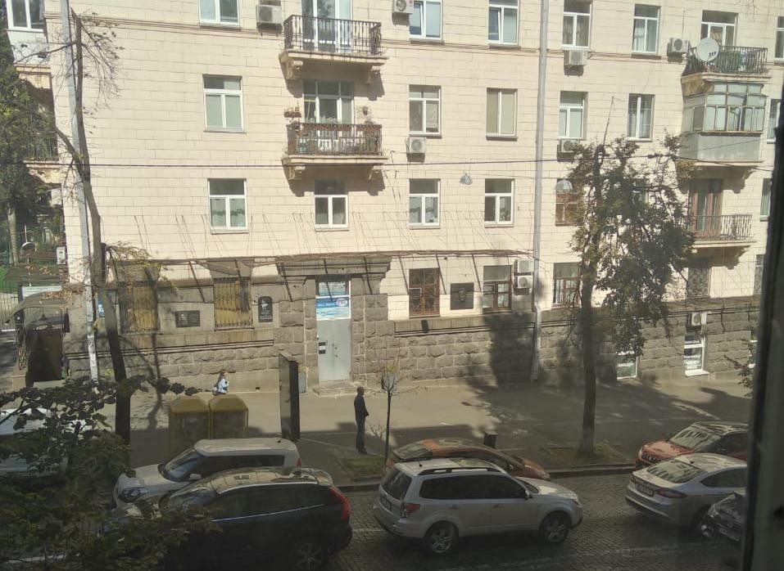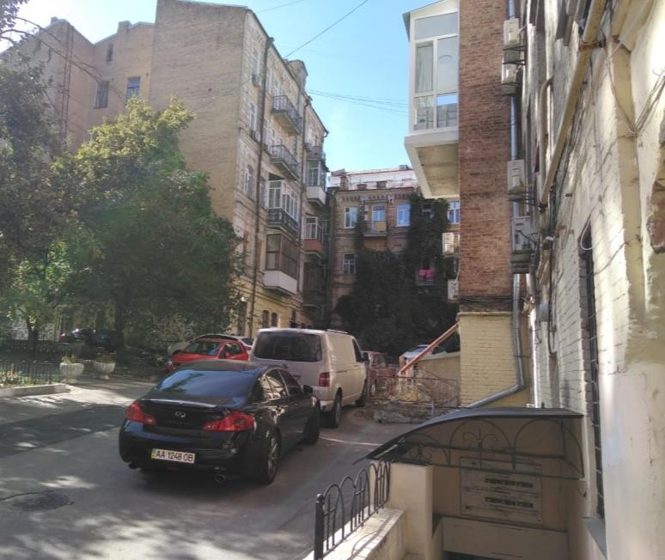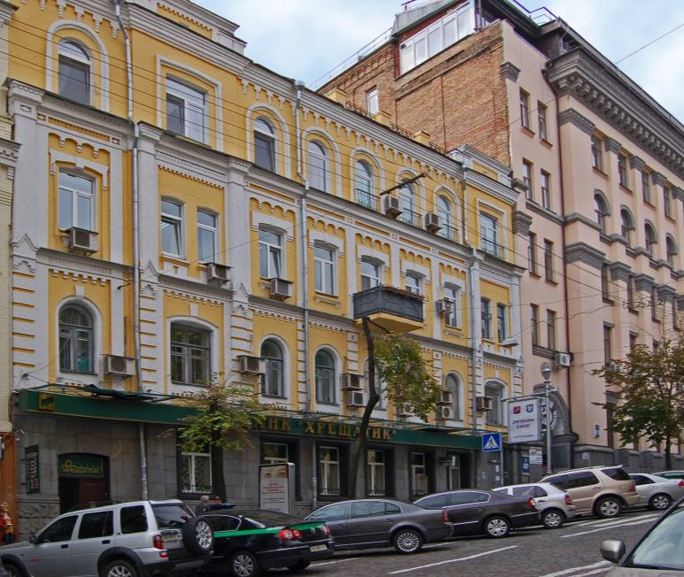
Real estate
investment opportunities in Ukraine
via participation in public auctions

Opportunity: 5 apartments grouped in 3 lots

Status: auction date 5 October 2019
Address: Prorizna St, 11, Kyiv, Ukraine
LOT 1 | m2 |  | LOT 2 | m2 |  | LOT 3 | m2
apt 5 | 69.9 |  | apt 2 | 92.1 |  | apt 1 | 87.3
apt 6 | 66.9
apt 44 | 184.1
Start price | UAH 12,462,348 |  | Start price | UAH 3,587,779 |  | Start price | UAH 3,390,515
Start price | $ 508,667.27 |  | Start price | $ 146,439.94 |  | Start price | $ 138,388.36
Start price per m2 | $ 1,585.13 |  | Start price per m2 | $ 1,590.01 |  | Start price per m2 | $ 1,585.20

Legal aspect: no legal issues, currently offices of bank in liquidation “Khreschatyk”

Advantages:

- 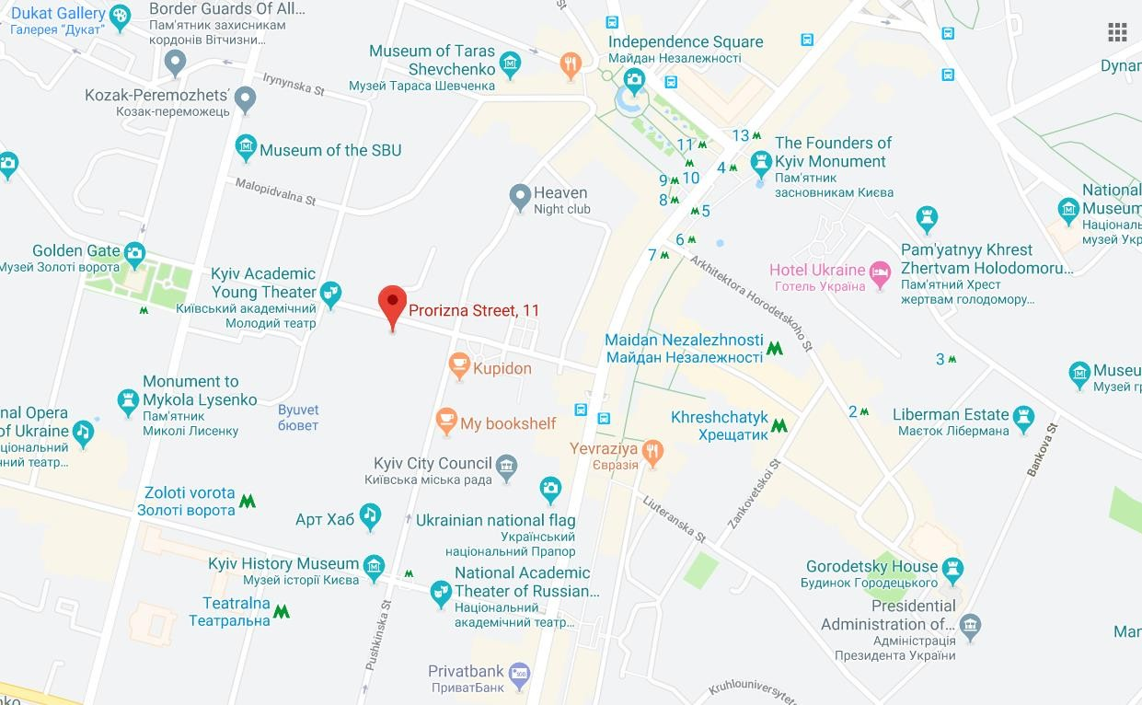Central location, 1 min walk from the main street Khreschatyk

- Ready to rent out as an office or to be refurbished for an apartment

- Historical and beautiful building

Challenges:

- Increased interest to the property and expected competition at the auction

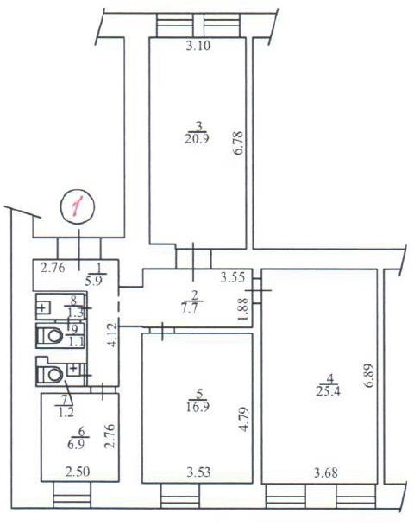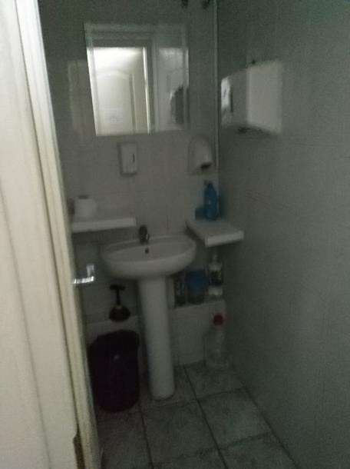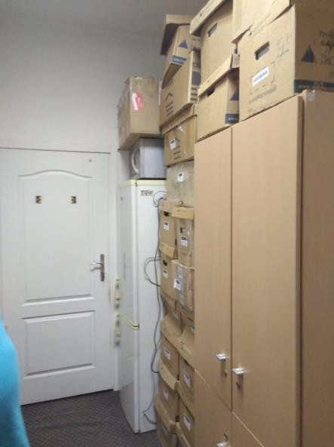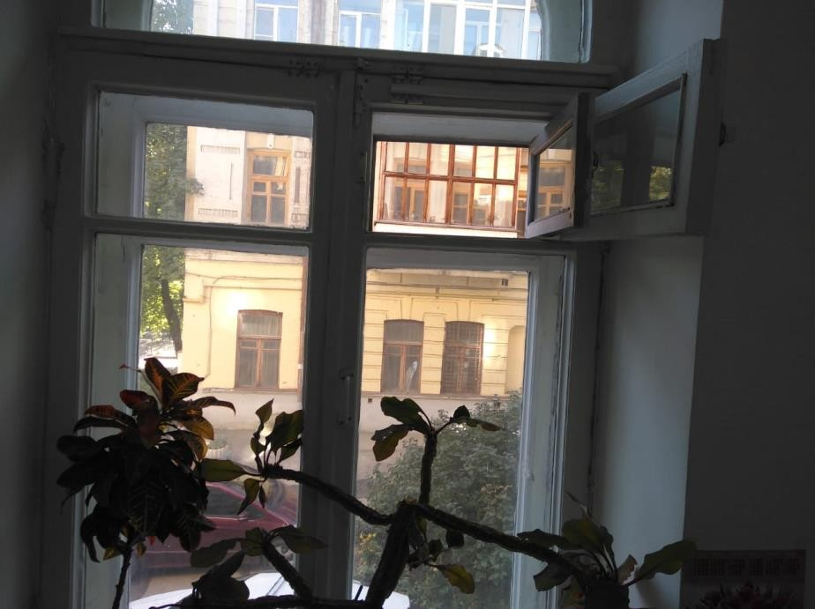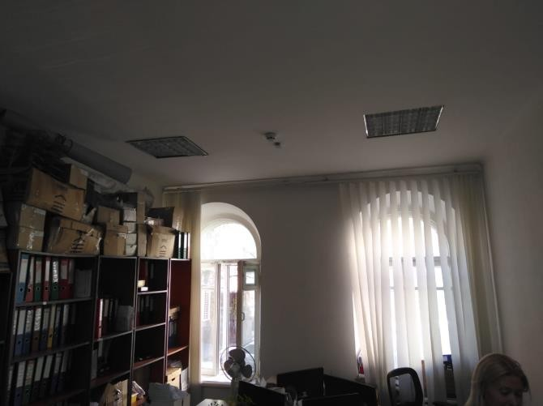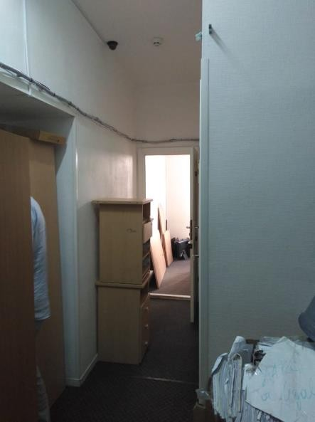Opportunity: Lot 3 – apt №1 on the 2nd floor

Status: auction date 5 October 2019

Opportunity: Lot 3 – apt №1 on the 2nd floor

Financials

 | Target Acquisition Price | Charges | miscellaneous expenses | refurbishment | TOTAL acquisition costs | TOTAL INVESTMENTS | Exit date | Exit Price total | Exit costs | NET Gain | MoIC | ROI (annualised, net of fees)
Scenario 1 | $166,066 | $10,188 | $500 | $1,000 | $11,912 | $177,978 | Oct-20 | $215,456 | $21,773 | $15,706 | 1.09 | 9%
Scenario 2 | $166,066 | $10,188 | $500 | $1,000 | $11,912 | $177,978 | Oct-20 | $233,964 | $29,435 | $26,551 | 1.15 | 15%
Scenario 3 | $166,066 | $10,188 | $500 | $39,285 | $50,197 | $216,263 | Oct-20 | $282,852 | $34,859 | $31,730 | 1.15 | 15%

Important:

auction guarantee 5% of the starting price to be paid 2-3 working days before each auction date

in case of not winning an auction the deposit guarantee is returned in full within 2 working days

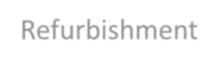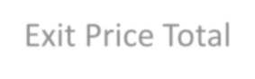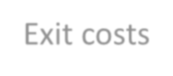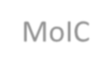Description of terms and assumptions:
Target acquisition price Charges
Miscellaneous expenses Refurbishment
Exit Price Total Exit costs
Net Gain MoIC
RoI
is likely to be higher than the starting price due to the competition during the auction, max 120% from the start incl. notary, pension fee, state tax, trade platform fee, management fee
incl. charges for utility bills, etc
assumed 1000 for cleaning and small maintenance, and in Scenario 3 assumed 450USD/m2 for full refurbishment will depend on the market, rental income is included
incl. notary, military charge, pension charge, real estate broker fee, performance fee, income tax
final investor’s profit
multiple of invested capital after fees and costs (not annualised) return on investment annualised after fees and costs (annualised)

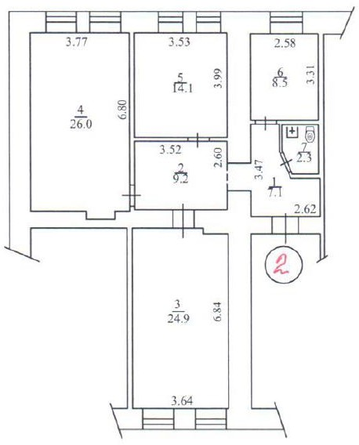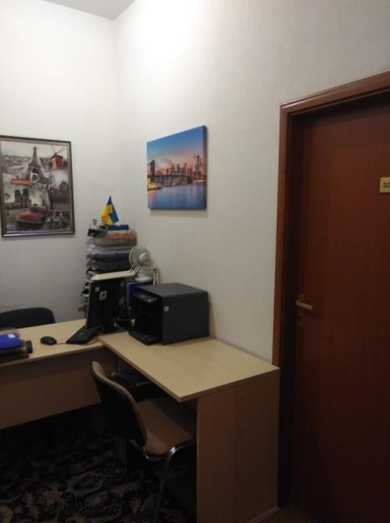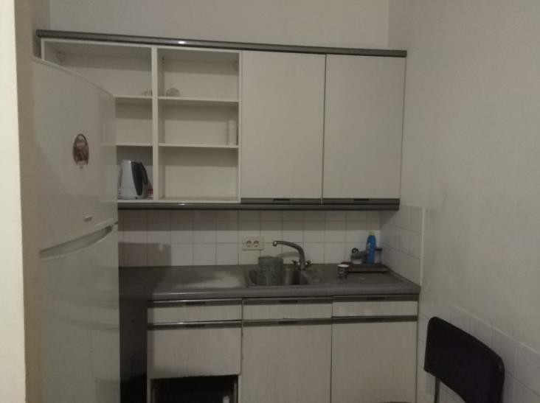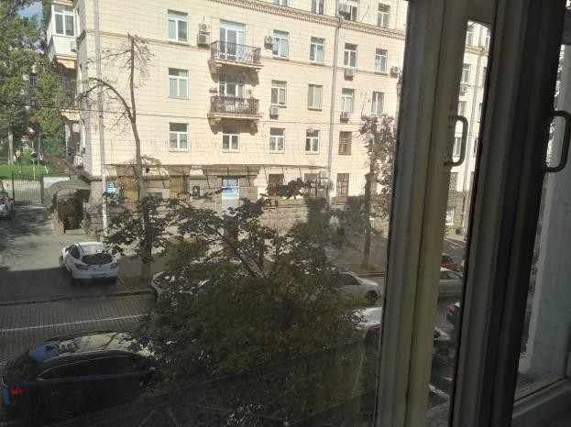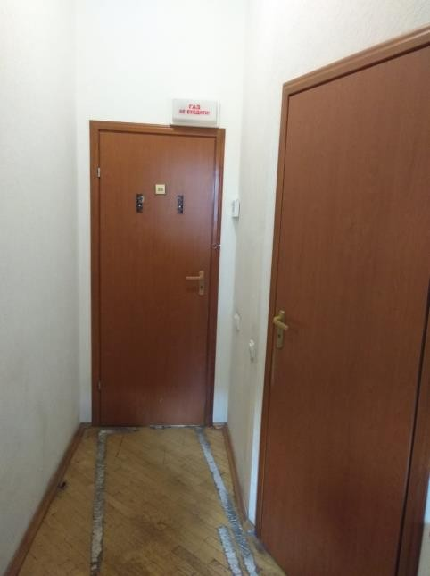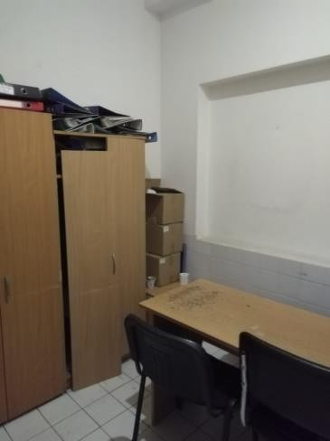Opportunity: Lot 2 – apt №2 on the 3rd floor

Status: auction date 5 October 2019

Opportunity: Lot 2 – apt №2 on the 3rd floor Financials
 | Target Acquisition Price | Charges | miscellaneous expenses | refurbishment | TOTAL acquisition costs | TOTAL INVESTMENTS | Exit date | Exit Price total | Exit costs | NET Gain | MoIC | ROI (annualised, net of fees)
Scenario 1 | $175,728 | $10,768 | $500 | $1,000 | $12,504 | $188,232 | Oct-20 | $227,303 | $22,134 | $16,937 | 1.09 | 9%
Scenario 2 | $175,728 | $10,768 | $500 | $1,000 | $12,504 | $188,232 | Oct-20 | $246,828 | $30,161 | $28,435 | 1.15 | 15%
Scenario 3 | $175,728 | $10,768 | $500 | $41,445 | $52,949 | $228,677 | Oct-20 | $298,404 | $35,721 | $34,006 | 1.15 | 15%

Important:

auction guarantee 5% of the starting price to be paid 2-3 working days before each auction date

in case of not winning an auction the deposit guarantee is returned in full within 2 working days

Description of terms and assumptions:
Target acquisition price Charges
Miscellaneous expenses Refurbishment
Exit Price Total Exit costs
Net Gain MoIC
RoI
is likely to be higher than the starting price due to the competition during the auction, max 120% from the start incl. notary, pension fee, state tax, trade platform fee, management fee
incl. charges for utility bills, etc
assumed 1000 for cleaning and small maintenance, and in Scenario 3 assumed 450USD/m2 for full refurbishment will depend on the market, rental income is included
incl. notary, military charge, pension charge, real estate broker fee, performance fee, income tax
final investor’s profit
multiple of invested capital after fees and costs (not annualised) return on investment annualised after fees and costs (annualised)

Timeline

AD – 2D Auction guarantee payment (5% of the starting price )

Auction Day Participation in the Dutch auction (descending price): Bid up to 130% of the start price AD + 3D If the winner, to sign a protocol of the auction
AD + 20D Deadline to make a full payment and sign a contract of purchase with the bank to become property’s owner

AD + 25D Property marketing, refurbishment and renting out

AD + 360D Target exit date to re-sell the property (assumed 1 year)

Exit and marketing

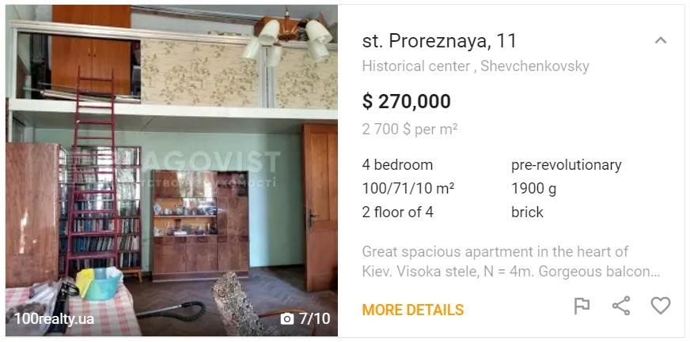
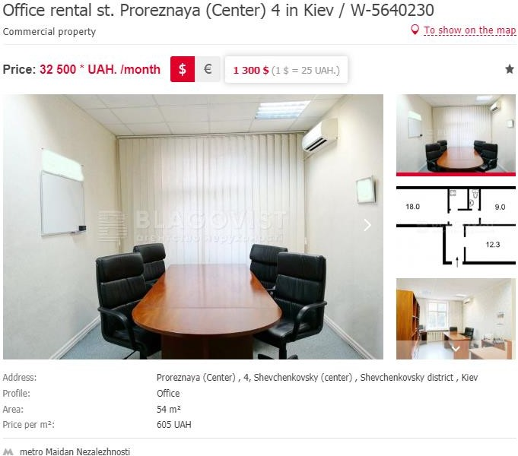
There is only 1 apartment on sale in that building:

- Needs refurbishment and is sold for $2700 per m2
Limited offer for rent in the area:

- Prices from 14 to 20 USD per m2 per month depending on the condition of the office

